ITWS- 6600 Data Analtics

A Project report on: vulnerability Analysis of aircraft landing facilities based on wind factor

LEVEL: 6000

Github - <https://github.com/rajpootmegha7/dataanalytics.git>

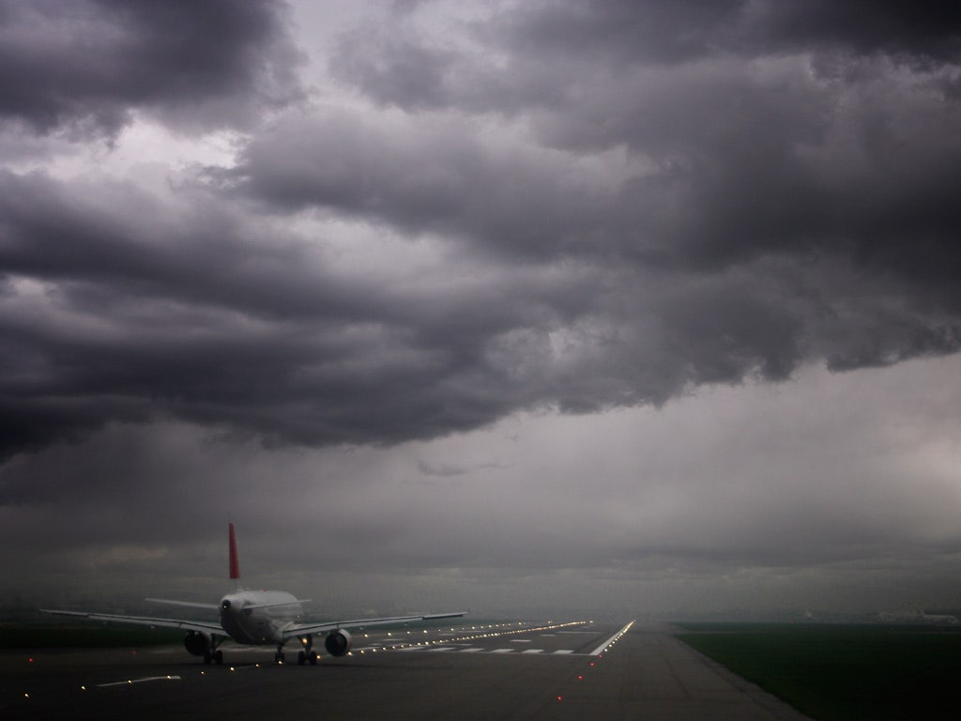

Submitted to:

Prof. thilanka Munasinghe

submitted by:

Megha singh rajpoot

RIN – 662019306

# **Abstract**

A strong surface wind can greatly affect an aircraft coming into land, causing turbulence and significant changes in speed, heading and altitude. If headwinds are slowing aircraft down, they take longer to land. In addition to reducing runway throughput, this increases airborne holding, which impacts the airspace. In addition, if winds reach a certain strength, airport ground operations are also restricted since the use of some airfield equipment, such as jet bridges, can be prohibited, causing potential traffic delays. In this paper, I examine the impact of daily and monthly wind collected from NASA merra-2 data on aircraft facilities between 2018 and 2020. I have applied K-Means, Mean-Shift, Heatmap and Optics Clustering to identify the top areas of extreme vulnerability.

# Introduction

According to the FAA, NTSB Records, & Fujita, 831 deaths were caused by wind shear from 1956 to 1994, or 700 deaths from 1970 to 1985. US Aviation Safety Network (ASN) data indicate that over 90 people were killed in at least two major accidents caused by wind shear between 1990-2000. As well, wind shear has been suspected to have played a major role in several recent accidents, like the TANS Airlines crash in Peru (2005), and the FedEx cargo plane crash in Japan (2009).

## Wind Shear

Wind shear is a change in wind speed and/or direction over a short distance. It is just one of the many unpleasant aspect of thunderstorms. The two worst problems outside actual storm penetration are shear related. These are the “first gust” and the “downburst.” The rapid shift and increase in wind just before a thunderstorm hit are the first gust.

These winds can change direction by as much as 180 degrees and reach velocities of 100 knots as far as 10 miles ahead of the storm. The gust wind speed may increase by as much as 50 percent between the surface and 1,500 feet, with most of the increase occurring in the first 150 feet. It can occur either horizontally or vertically and is most often associated with strong temperature inversions or density gradients.

Horizontal Wind Shear:

Horizontal wind shear and vertical wind shear are two types of wind shear. Although each component affects an aircraft simultaneously, it is easier to discuss each separately. An airplane's flight path passes through a wind shift plane when it experiences horizontal shear.

Vertical Wind Shear:

Most often, vertical wind shear is associated with an approach. Near the ground, vertical shear is common and can have the greatest impact on an aircraft. A change in velocity or direction can drastically alter lift, indicated airspeed, and thrust requirements. This can be beyond the pilot's ability to recover.

Effects of Wind Shear on Aircraft:

The aircraft is affected by the change in wind direction/velocity because the wind also affects its motion relative to the ground. High enough for recovery - Suppose that an aircraft is stabilized on an instrument landing system approach and encounters a shear that results from a decreasing head wind. In such a case, a transient loss of airspeed and lift causes the aircraft to descend. Landing Long and Hot - Again, the initial reaction of the aircraft to the shear and the pilot’s correction are the same. In this case, however, if the pilot overcorrects and the aircraft goes above the glide slope with airspeed increasing sufficiently, the pilot does not have enough altitude to recover, and the aircraft may land long and hot.

I have narrowed down my work and decided to focus on the Washington in view of the recent unusual wind activities in the US.

# Data Collection and Processing

## 1. Homeland security foundation – aircraft landing facilities data

The Airports dataset includes all official and operational aerodromes as of July 16, 2020 and is part of the U.S. Department of Transportation (USDOT)/Bureau of Transportation Statistics (BTS) National Transportation Atlas Database (NTAD). The Airports database is a geographic point database of official operational aerodromes in the United States and U.S. Territories. Attribute data is provided on the physical and operational characteristics of the aerodrome, current usage including enplanements and aircraft operations, congestion levels and usage categories. This geospatial data is derived from the FAA's National Airspace System Resource Aeronautical Data Product [1].

This data contains 103 attributes [1] which contains different details regarding different airport facility types, their location information, owner’s details of the facilities, manager details, wind indicators etc. Topographical representation of all the facilities on the USA map is shown below:

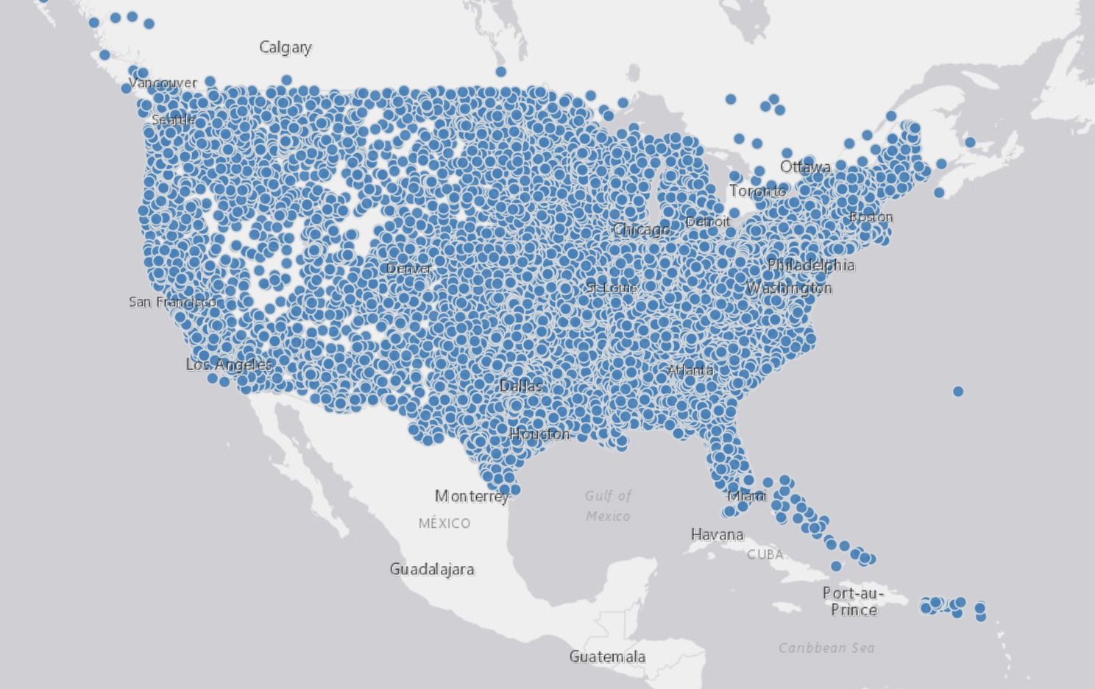

*Fig1: Aircraft facilities available in dataset*

For this project I have decided to consider Facility type as Airport and State as Washington. Therefore, I have applied filter over the values and received the output with 356 rows and 9 columns.

*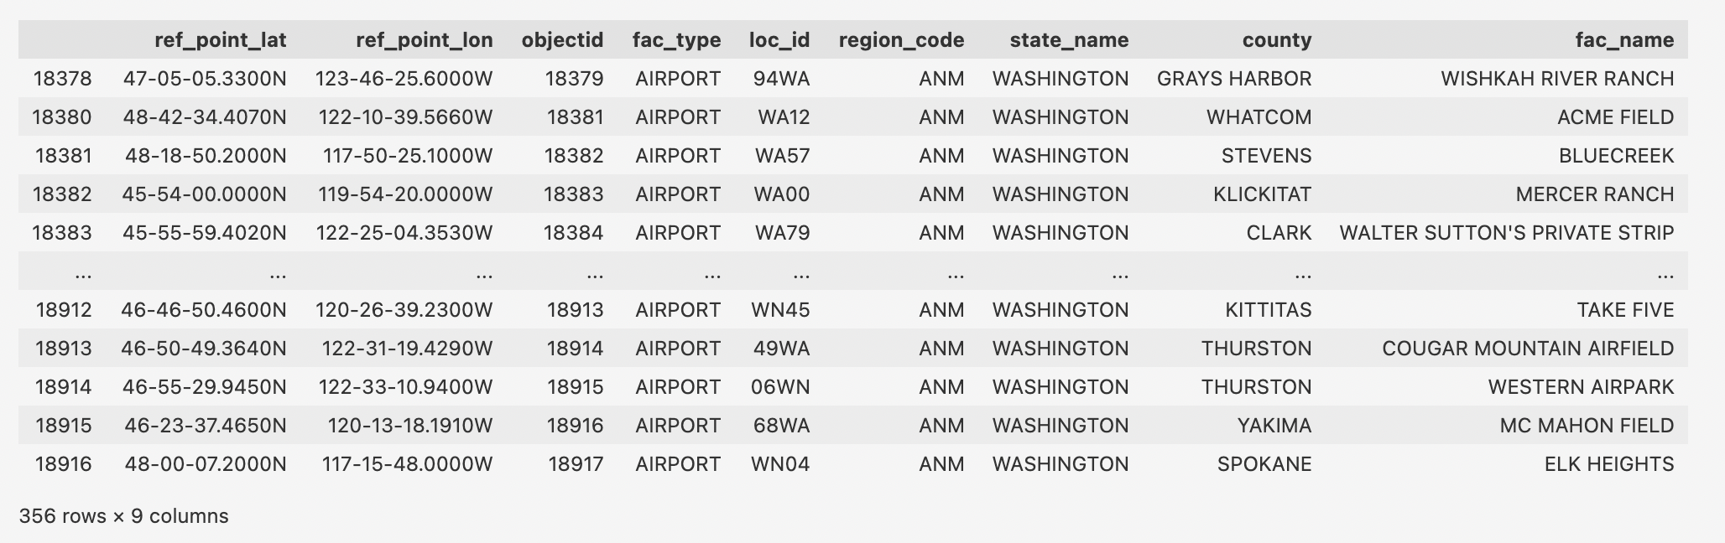Fig2: Airport Facility data frame*

## 2. Wind MERRA-2 tavg1_2d_slv_nx

M2T1NXSLV (or tavg1_2d_slv_Nx) is an hourly time-averaged 2-dimensional data collection in Modern-Era Retrospective analysis for Research and Applications version 2 (MERRA-2). This collection consists of meteorology diagnostics at popularly used vertical levels, such as air temperature at 2-meter (or at 10-meter, 850hPa, 500 hPa, 250hPa), wind components at 50-meter (or at 2-meter, 10-meter, 850 hPa, 500hPa, 250 hPa), sea level pressure, surface pressure, and total precipitable water vapor (or ice water, liquid water)[2].

We are using “50-meter eastward wind m/s” and “50-meter northward wind m/s” daily data in 30mintues time interval for region Washington in the form of Merra2-file in nc4 format.

Firstly, it is important to calculate wind speed from the above MIRRA-2 variables for analysis. To calculate that I am considering the eastward and northward wind components are represented by the variable “u” and “v” respectively. MERRA-2 positive u wind component is parallel to the positive x-axis (West to East), while the positive v component is parallel to the positive y-axis (South to North) [3].

Given the u and v wind components, calculating the wind speed using the Pythagorean Theorem:

Wind Speed = (u2+ v2)1/2

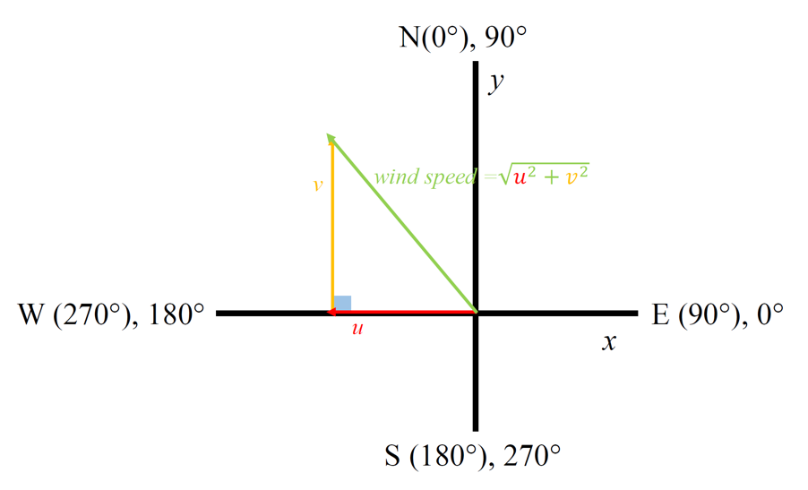

*Fig3: Wind speed calculations*

Even though I have downloaded the data, the files were in the netCDF format. Therefore, I have converted the files from netCDF4 format to CSV format by using online reference [4].

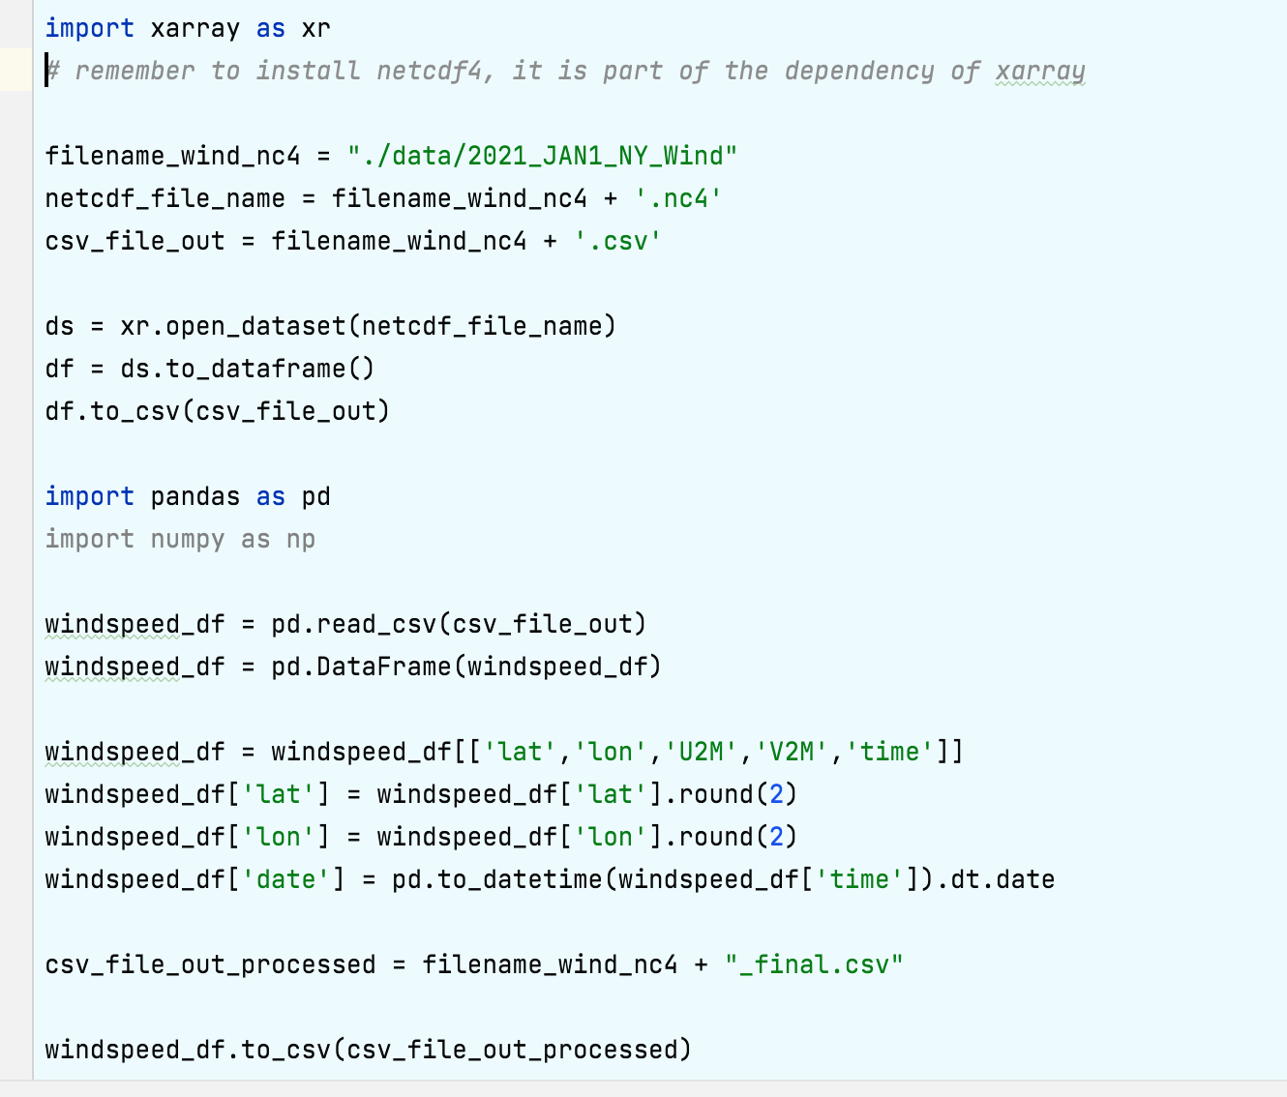

*Fig4: Conversion of netCDF to CSV*

## 3. Data Processing

This was the most difficult part of the process because the Aircraft facilities latitude and longitudes were not matching with the wind data coordinates. Part of the plan was to assign the average wind speed to the matching coordinate. Therefore, an alternative solution for this problem described below:

1. Create a box using the four coordinates of wind coordinates.
2. Calculate the average wind speed of per day basis.
3. Whichever airport facilities lies between these boxes and assign the same average wind speed to each one of them for that day.

The above-mentioned algorithm is shared below in Fig5. This way new dataset is created with facilities details and attached average daily wind speed of those facilities.

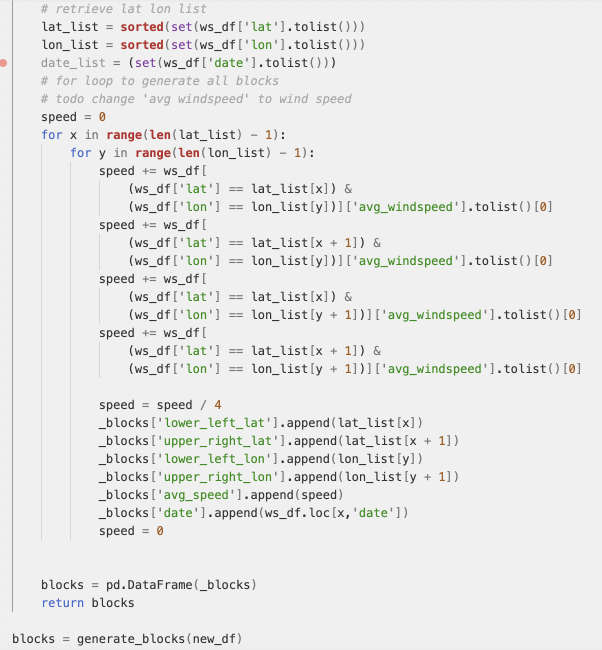

*Fig5: Algorithm to assign speed to facilities based on geo reference.*

As part of the data cleaning process, I have removed few unwanted columns. The dataset is clean with new average wind speed is defined for each month starting May 2020 till May 2021.

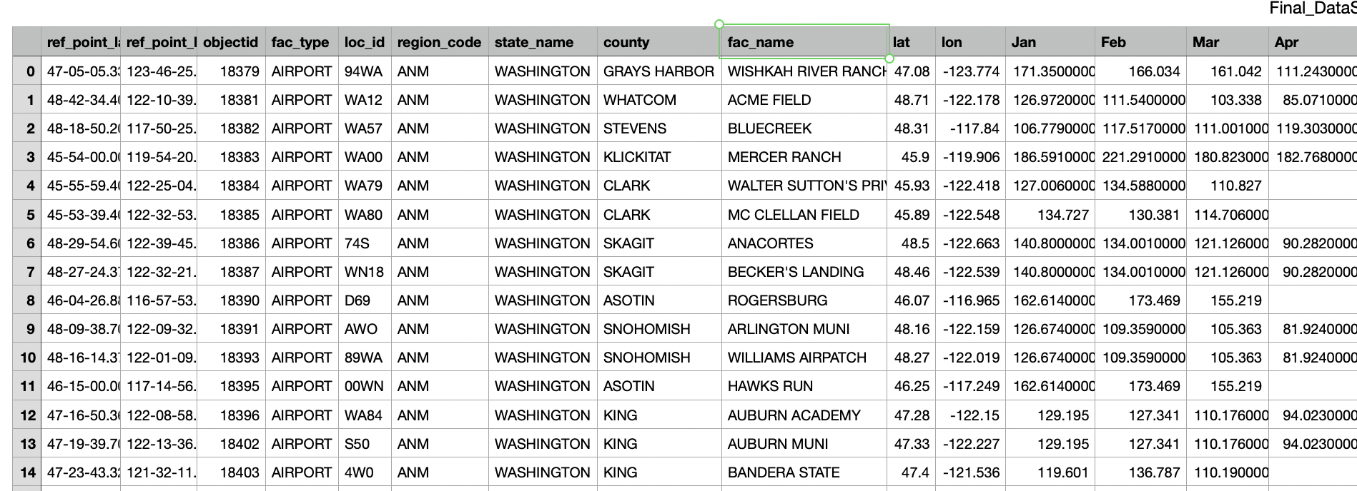

*Fig6: Partial display of data after assigning wind speed to certain location.*

## 4. Visualization of data

In this final dataset there are various county assigned with different average wind speed. In order to understand which county has the highest range of values for average wind speed during which month of the year, I have plotted line graph to compare the values and showcase the results.

While looking at the graph represented in Fig7, I have understood that average wind speed is highest for all the counties in the Month of May. Which represents the windiest month of the year 2020 and 2021.

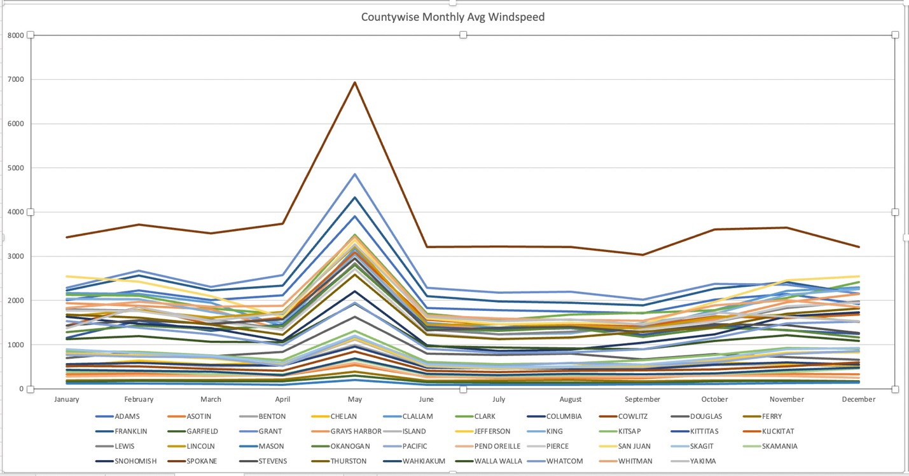

*Fig7: Average wind speed distributions for each county across months.*

Whereas, to understand that which county has the highest average of wind speed recorded for all months I have plotted another line graph Fig8. After analyzing this graph, I have understood that counties like Spokane, Grant and Franklin have highest recorded wind speed in the month of April and February, etc.

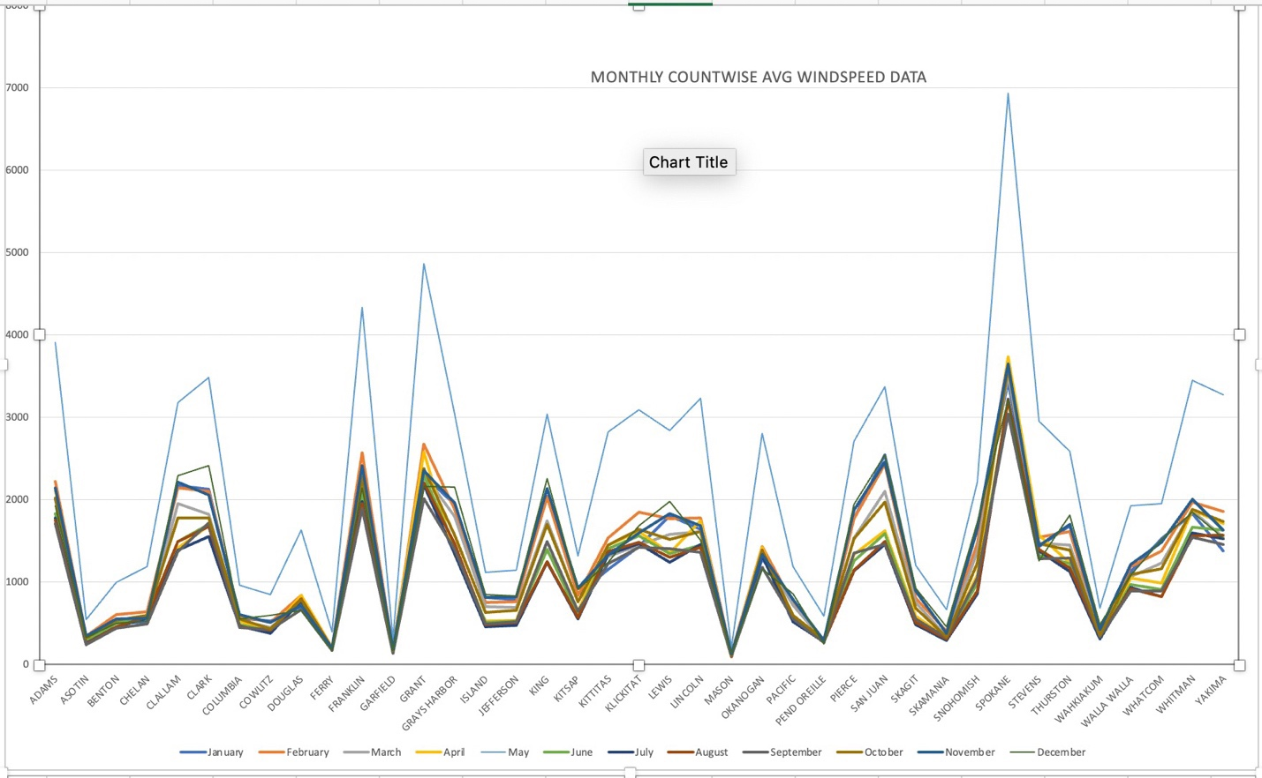

*Fig8: Average wind speed distributions of months for each county.*

## Uncertainity

Currently, the wind speed component data that I have considered at 50 meters. When the value of wind data changes to 250hpa or 500hpa this analysis might not be valid for those values. According to National Weather Services the wind speed 50 mph is considered high threat to life and property [8]. But these values are also dependent on the direction and temperature of winds, currently my values are based on average of both the wind components (eastwards and northwards winds).

# model development and applications

The main objective of this project is to calculate most vulnerable airport facilities in Washington state due to high wind speed. This means that it is not required to perform prediction through classification and regression models. Instead, I am using clustering techniques

## Clustering

Clustering is a Machine Learning technique that involves the grouping of data points [5]. Considering we have data points; we can use this technique to classify each data point into a specific group. Theoretically, data points which belongs to same group will have similar properties, otherwise vise-versa. This is a used as an unsupervised learning technique for statistical data analysis. I have used different kind of clustering algorithms to cluster airport facilities based on average wind speed data on those locations.

*The approach followed in this project is to cluster the counties based on different average wind data values and to find the most vulnerable airport facilities in Washington state.*

Following clustering techniques are implemented as part of multiple model requirements.

1. OPTICS Clustering
2. K-Means Clustering
3. Mean-Shift Clustering
4. Heatmap Clustering

Before application of these above-mentioned models few steps need to be executed as part of the EDA process. These steps will be applicable for all the models to transform the data and make them compatible. Steps are mentioned below:

* Convert the date columns into monthly columns while aggregating the wind data. Drop the date columns from data frame once new month columns are created.

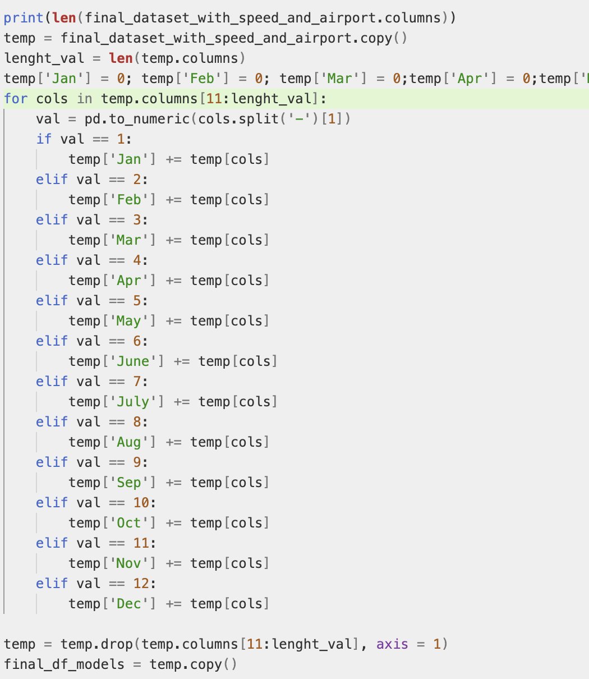

*Fig9: Create new columns for each month and drop the previous date columns.*

* Assign the category type for each county value and create a new column in the data frame.

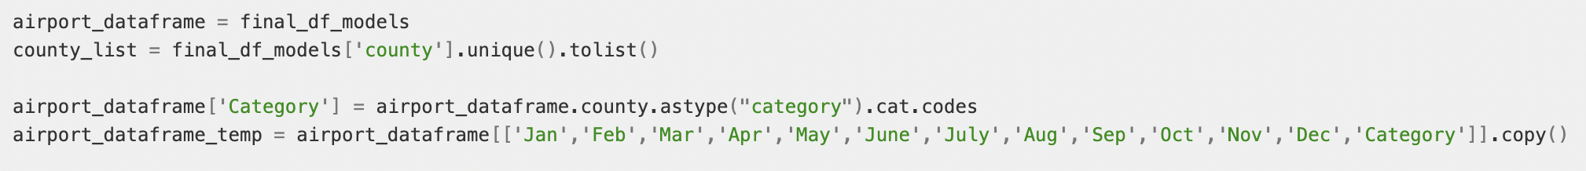

*Fig9: Assigning category and creating new data frame with month wise data*

* Normalize the data frame values.

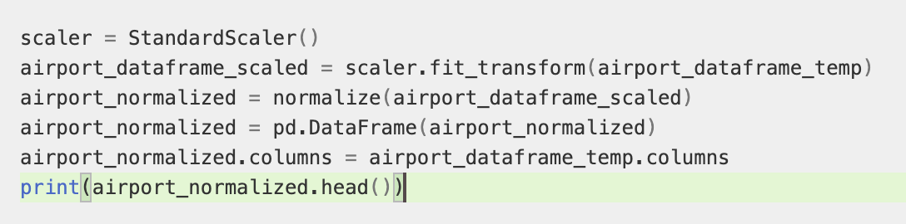

*Fig10: Normalization using Standard Scaler function*

## 1. Optics Clustering

OPTICS clustering is a powerful unsupervised knowledge discovery tool. It is an extension of DBSCAN but is less sensitive to parameter settings because it can find a clustering structure [6].

This method produces a special cluster-ordering of the data points with respect to its density-based clustering structure. The clustering order contains information equivalent to the density-based clustering corresponding to a broad range of parameter settings [7].

In order to, implement this model, I have followed below steps:

1. Building the clustering model.

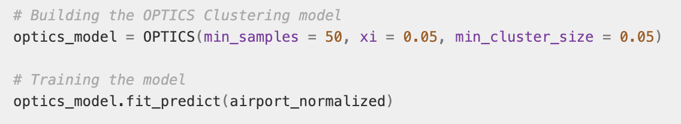

*Fig11: Building the clustering model.*

1. Application of optics dbscan using reachability, core distance, ordering and epsilon is shown in Fig12. I have stored the results and labels and output is shown in Fig13.

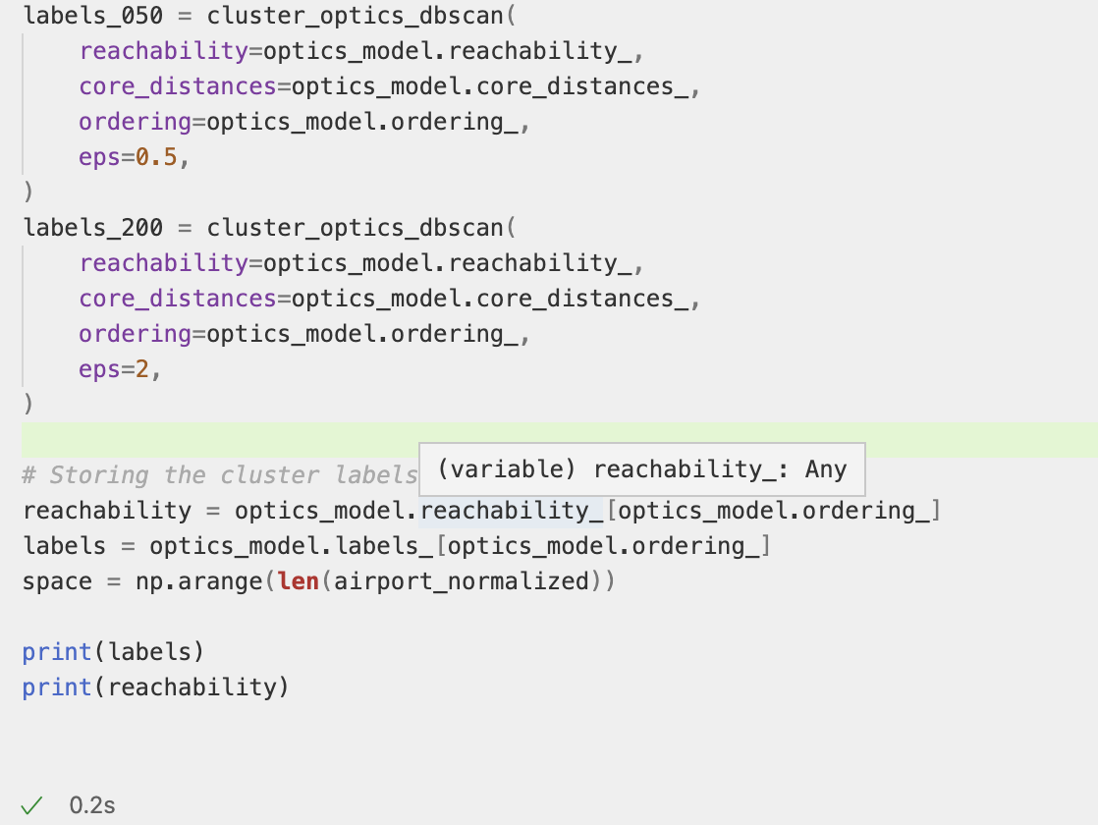

Fig12: Storing the result of training.

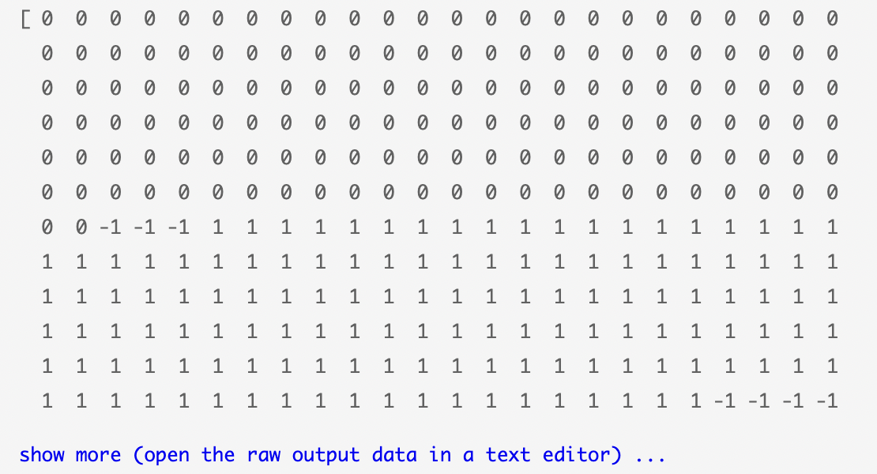

*Fig13: Output of label*

1. Visualization of results is performed in three plots. First plot Fig11a is referring the reachability plot and the depth of the valley represents the density of clusters. Fig 11b Optics clustering is representing the clusters of different counties based on the average wind speed values of different months. I have noticed that two clusters are formed, and the remaining grey color are the noises/outliers.

DBSCAN epsilon cut at 0.5 and 2.0, have created two dense cluster in light green and dark green colors based on the dataset normalized values.

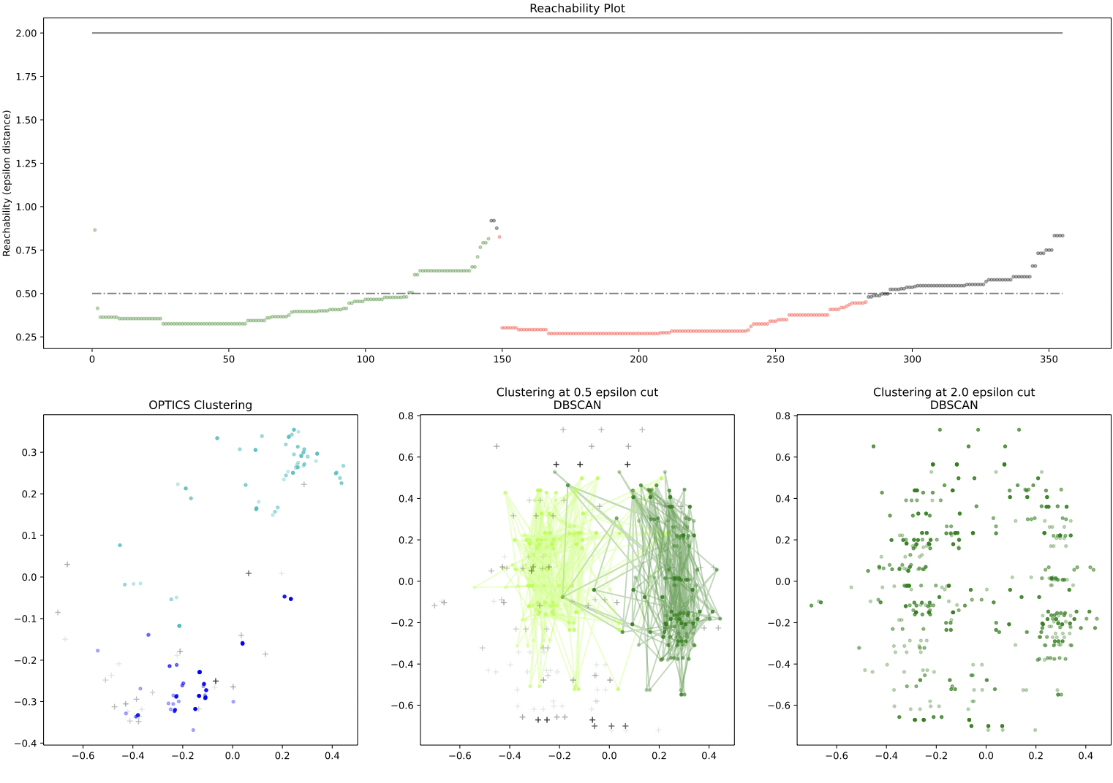

*Fig11: Reachability plots and dBSCAN disk*

## 2. K-Means clustering

K Means clustering requires selection of optimum number of clusters ‘k’ before application of model. I have applied two elbow methods to calculate value of k. While looking at Fig12a and Fig12b, I have analyzed the elbow cut value at 5.0. Hence, I have taken k=5 for my model application data.

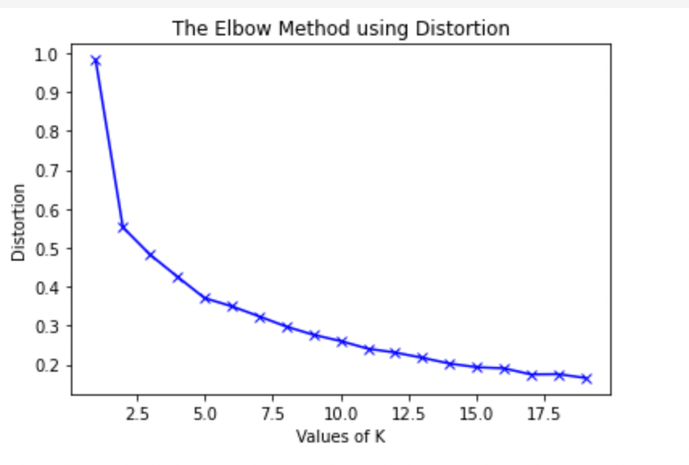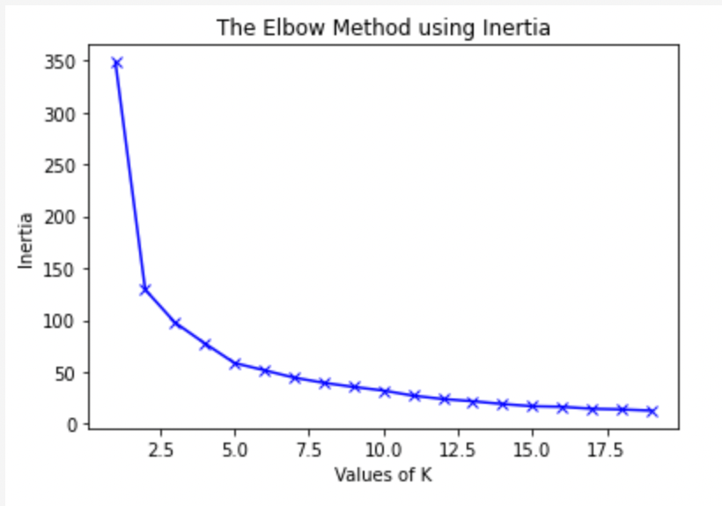

*Fig12a: Elbow using distortion*  *Fig12b Elbow using inertia*

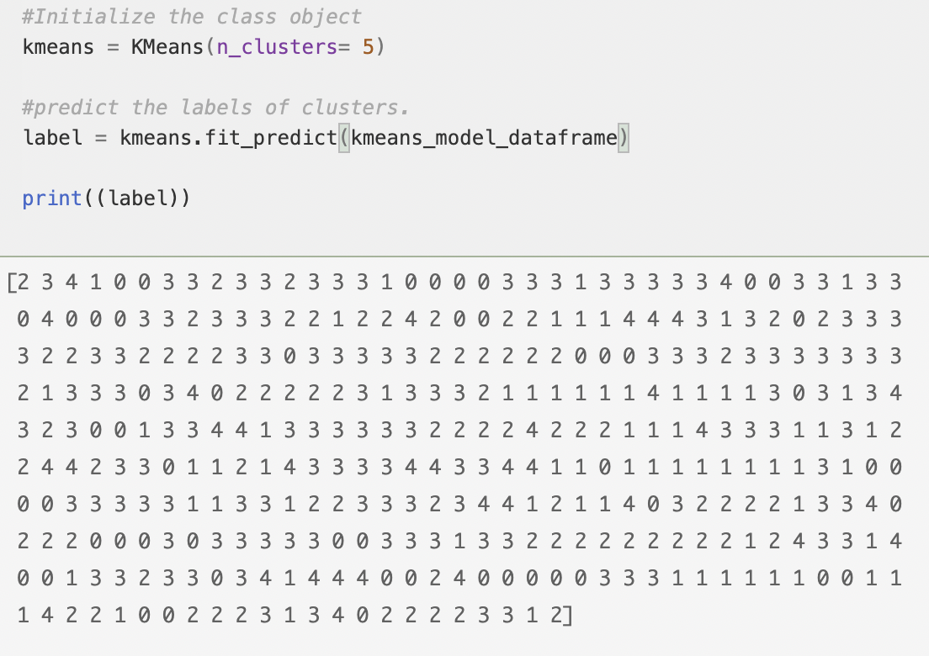

*Fig13: Initialization and predicting the labels of clusters.*

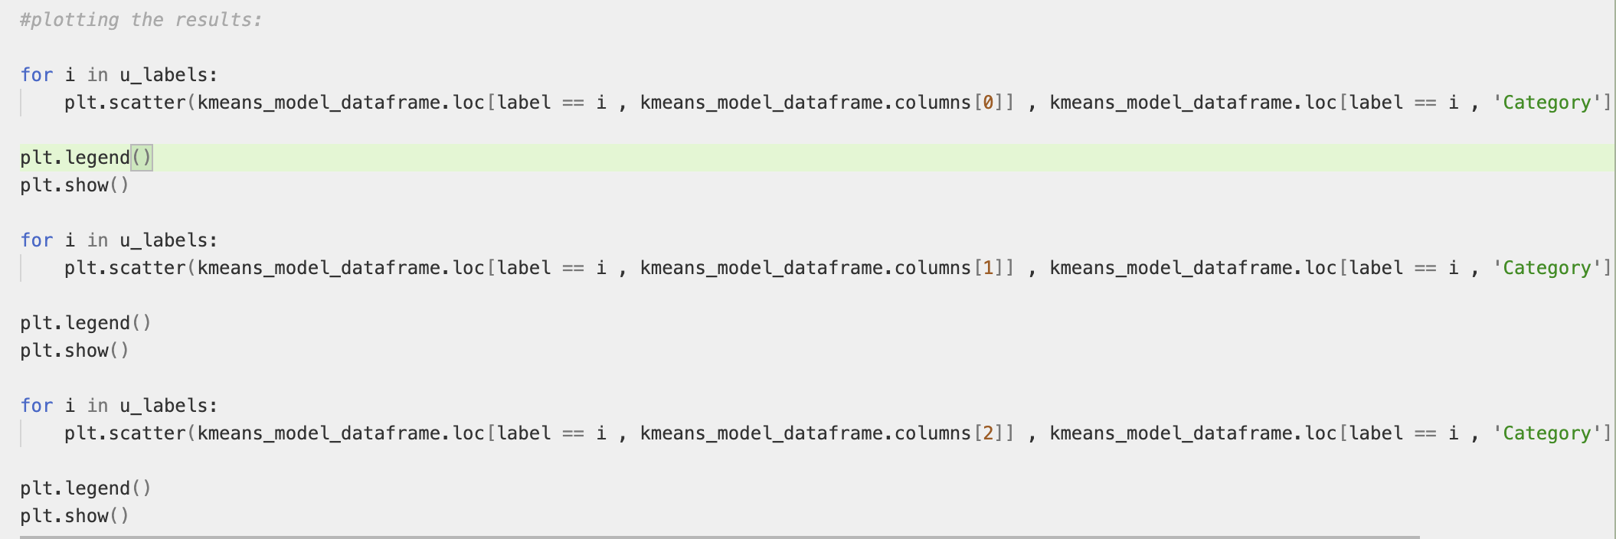

*Fig14: Applying k means clustering*

To understand the month wise data clusters in details below Fig15 represents the cluster information for the month of May. Below mentioned cluster represents 5 clusters for the month of May. Colors represents the counties and I have noticed better clusters formations for the values near 275, 350 and 200 which are total of average wind speed value for counties (Y-axis) added as Category during data processing.

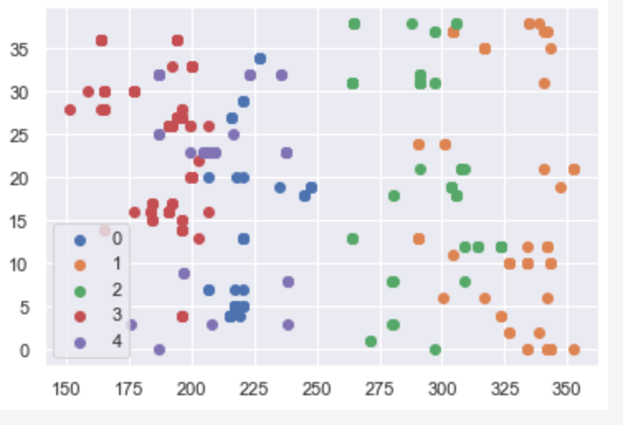

*Fig15 Monthly K-Means clustering- May*

Above mentioned cluster represents 5 clusters for the month of May. Colors represents the counties and I have noticed better clusters formations for the values near 275, 350 and 200 which are total of average wind speed value for counties (Y-axis) added as Category during data processing.

Similarly, after comparing the clusters for remaining months the green and orange clusters are intact. Maximum cluster speed values are distributed among all the counties.

## Mean shift clustering

Mean shift is falling under the category of a clustering algorithm in contrast of Unsupervised learning that assigns the data points to the clusters iteratively by shifting points towards the mode (mode is the highest density of data points in the region, in the context of the Mean shift). As such, it is also known as the Mode-seeking algorithm [9].

Unlike K-Means this doesn’t require to define cluster in advance. It will be defined by the algorithm. In the below Fig16 Mean Shift clusters are created:

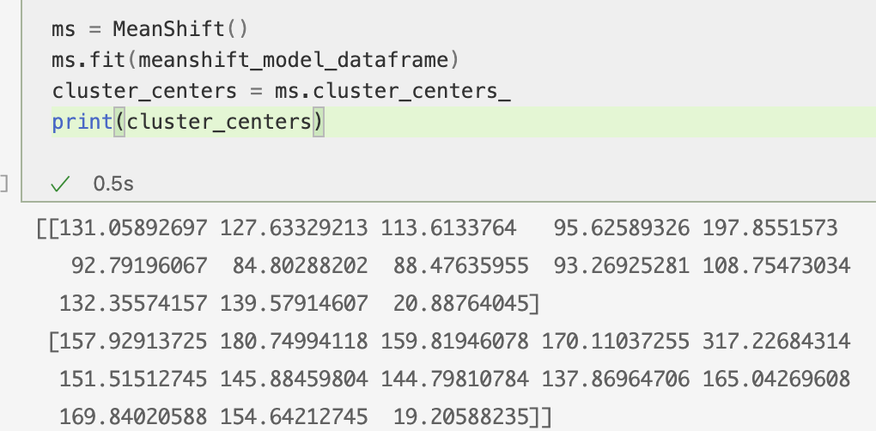

Fig16: Creating clustering centers

After plotting the cluster for values of all the months the cluster values are high density values are shifted towards the low average wind speed values. Which represents that the maximum clusters of counties have low wind speed values for the entire year at 50 meter height.

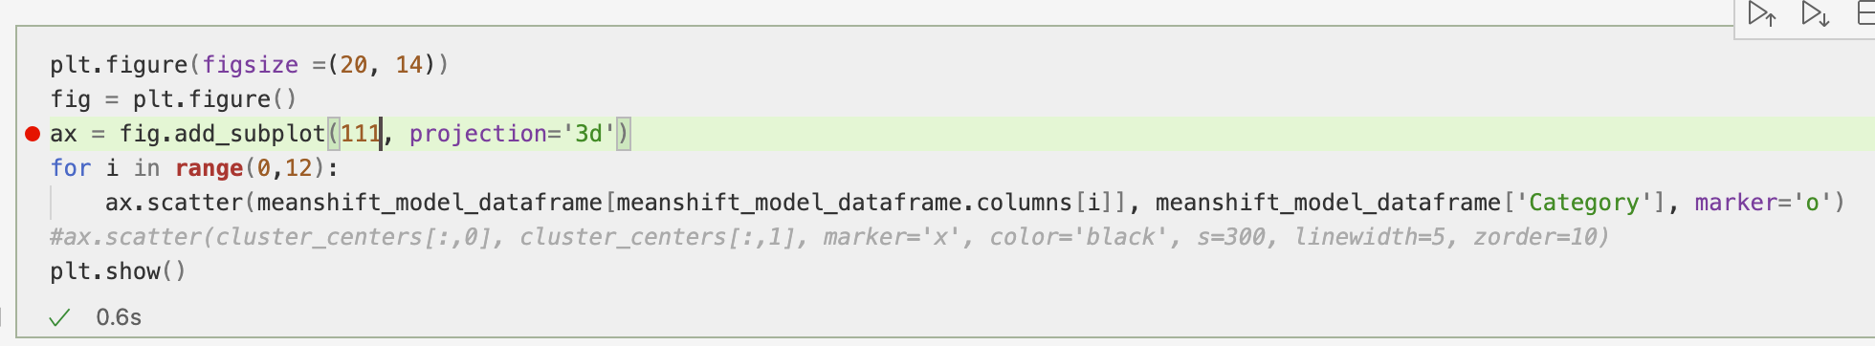

Fig17: Adding the 3d dimensional plot.

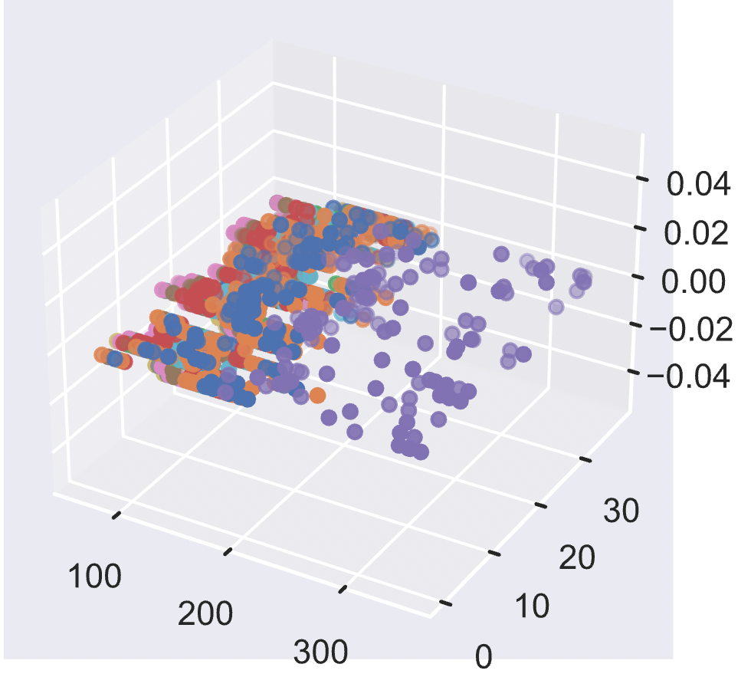

Fig18: Scatter Plot for a year of dataset

To visualize the data in the better way, I have segregated the values for single month in Fig19. In the graph below I have noticed that the clusters were shifted towards lower wind speed values between 60-80 for the month of April, May and June. Whereas, for the month of Nov and dec they are shifted between 100-150.

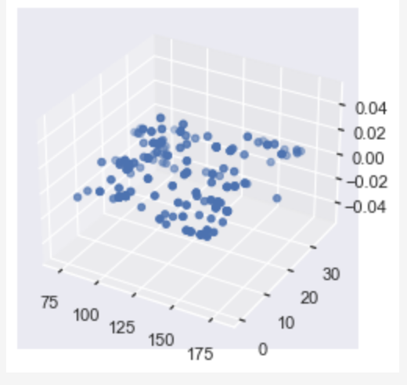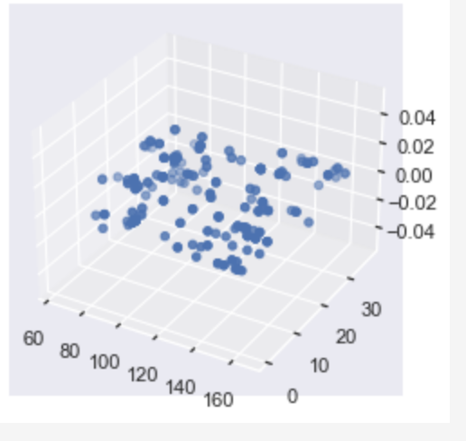 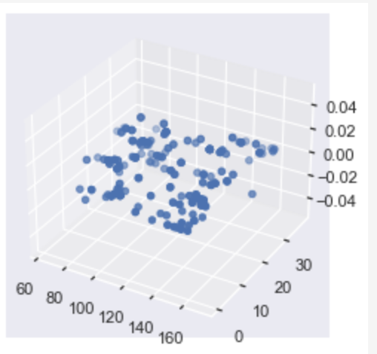

Fig19a: Clusters for April Fig19b: Clusters for May. Fig19c: Clusters for June

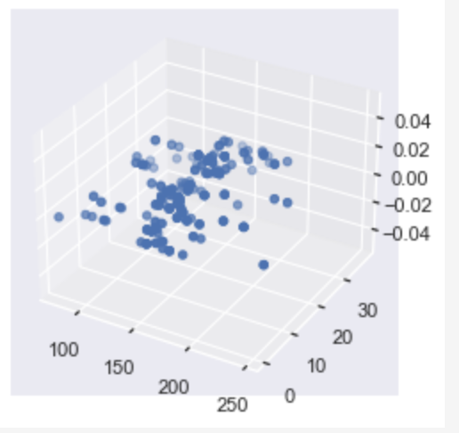 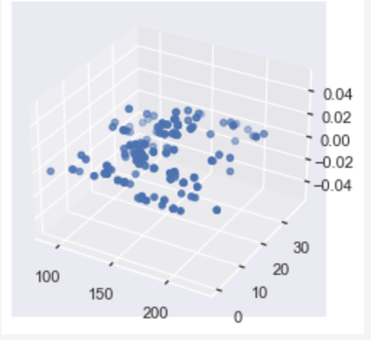

Fig19d: Clusters for dec Fig19e: Clusters for Nov

## Heatmap clustering

Firstly, I am using dendrograms to display a hierarchical the results of a heatmap and form clusters around it. I started with the default heatmap as shown below.

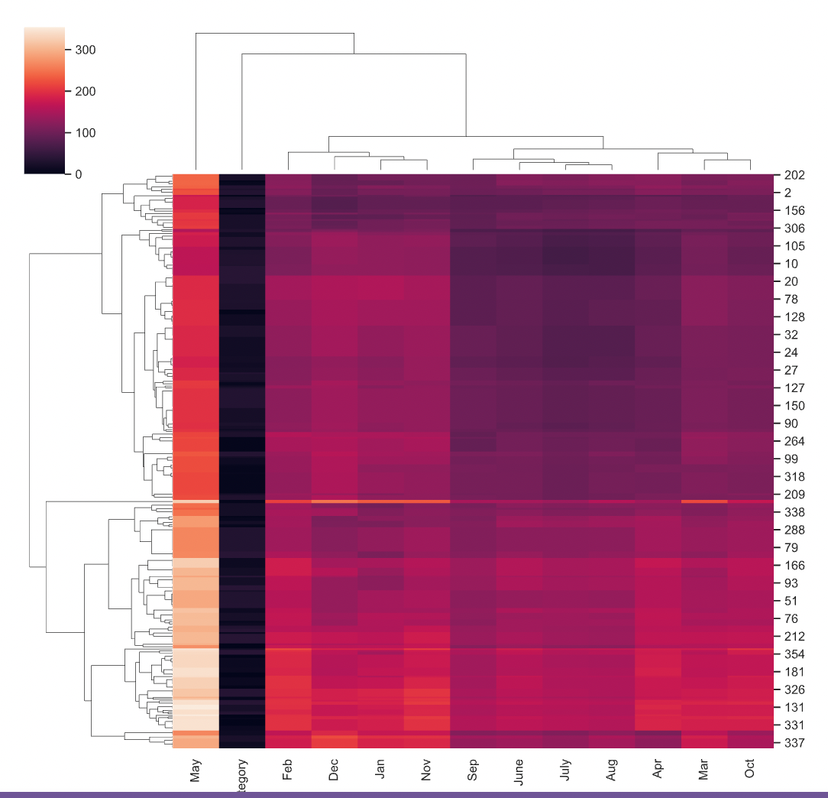

Fig20: Default heatmap for airport data frame

Then I changed the dataset to form a normalized heatmap using seaborn library and results are shown in Fig21. In below represented heatmaps X-axis represents the months starting Jan-1 to Dec-12 and Category is represented as 0. Whereas Y-axis represents the total number average speed for Washington state counties.

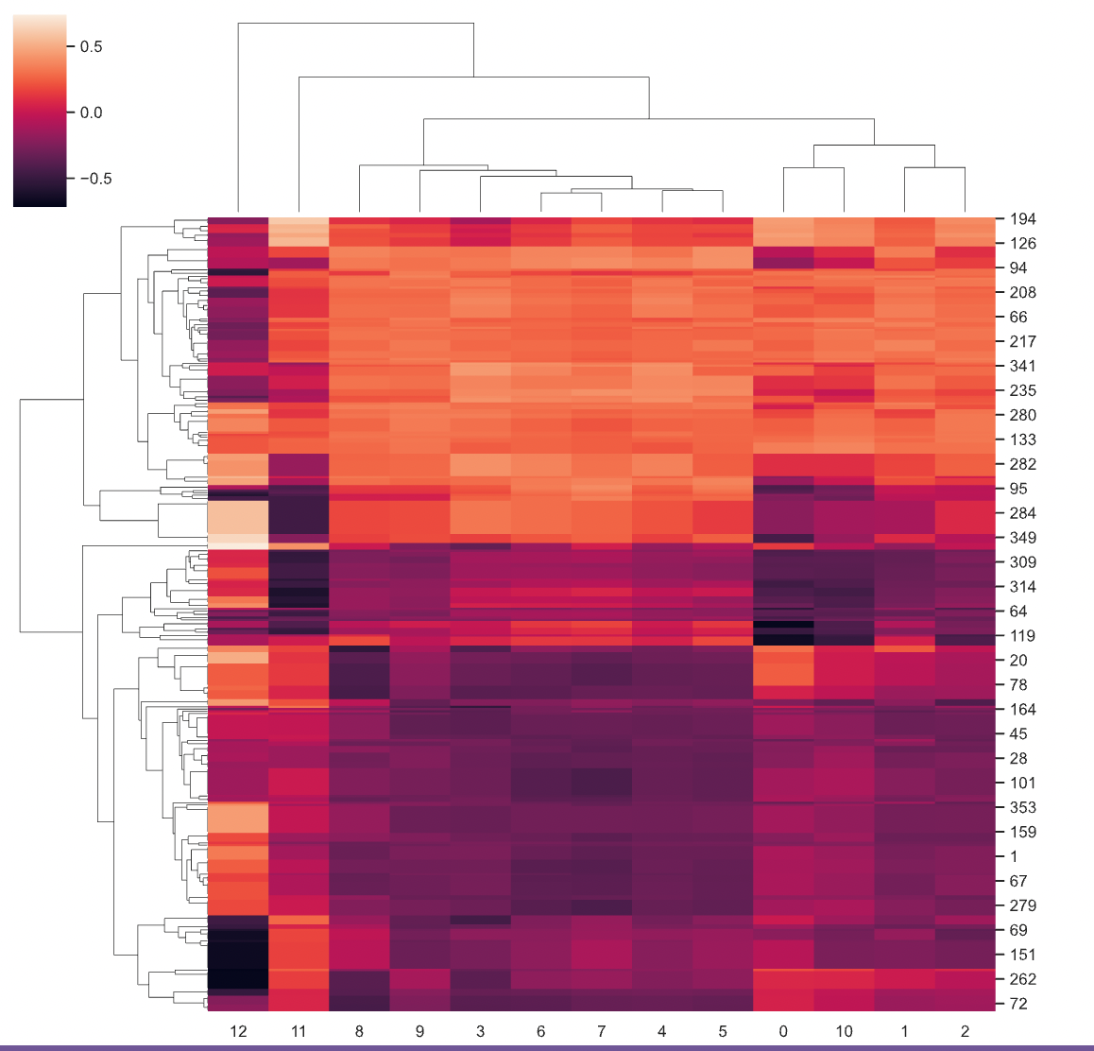

Fig21: Default Normalized Heatmap of average wind speed of all counties over the period of a year.

Secondly, I used the different distance metrics for the same data using matric parameter. In Fig22 I have used correlation distance.

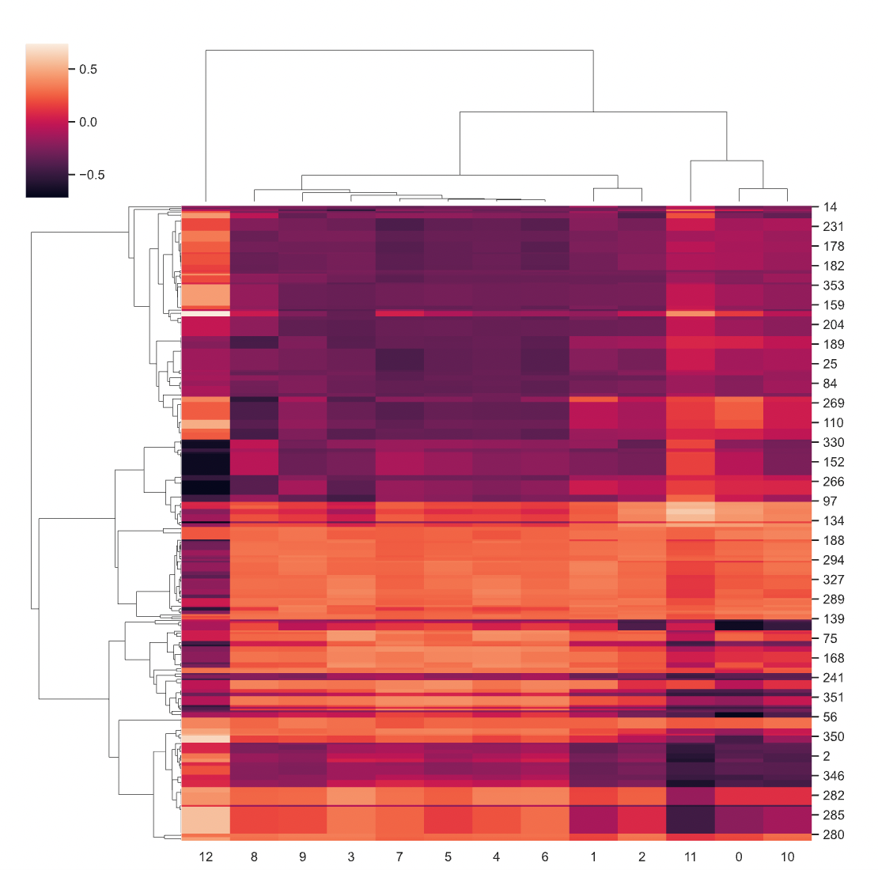

Fig22: Correlation method for airport facility dataset

At last, after determining the distance using correlation method. I have tried to set the linkage method to use for calculating clusters with the method parameter as shown in Fig23. I have noticed some pattern formation near the month of (April, May, and July), (Nov and Oct) etc.

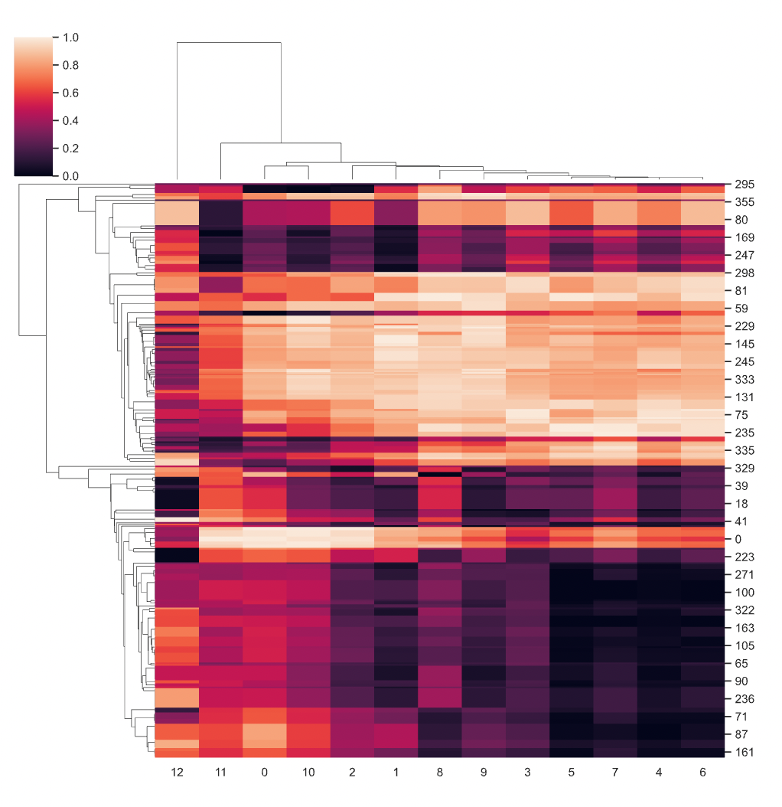

Fig23: Clusters for airport facilities using total wind speed data.

# Conclusion and discussion

Main goal of this project is to cluster the counties based on different average wind data values and find the most vulnerable aircraft facilities in Washington state. Also, which month of the year these counties are most effected due to these strong winds.

## Interpreting the results

The clusters plotted using Heatmap and K-Means clustering and is considered the best algorithms for finding out the most vulnerable counties against extreme high-speed winds at the height of 50 meters. In Heatmap I have noticed some pattern formation near the month of (April, May, and July), (Nov and Dec) etc. After further analysis of various wind speed data Nov and Dec months have the highest recorded data for the counties lying between 0 and 20.

After analyzing K-Means clustering below are the most vulnerable counties in the Month of May, Nov and Dec with the highest wind speed records as shown in Fig15 in orange-colored clusters.

During the month of Nov these has recorded the strong wind speeds comparative to other. Airport facilities under this county are most vulnerable facilities.

|  |  |  |
| --- | --- | --- |
| Sr. no. | County | Month |
| 1. | Adams | May |
| 2. | Lewis | May |
| 3. | Clark | Nov and Dec - |

Table1.0: Most vulnerable counties in Washington state.

Most vulnerable Airport Facilities in the month of May, Nov and Dec are mentioned in Table2.0 below:

|  |  |  |
| --- | --- | --- |
| RISKY AIRPORTS - MAY | RISKY AIRPORTS- NOV | RISKY AIRPORTS - DEC |
| SKYQUEEN | OAKESDALE | WALTER SUTTON'S PRIVATE STRIP |
| CHEHALIS-CENTRALIA | OCHOA FLD | MC CLELLAN FIELD |
| FANTASY FIELD AIRSTRIP | OTHELLO MUNI | GOHEEN |
| DWIGHT FIELD | TREE HEART RANCH | CEDARS NORTH AIRPARK |
| CURTIS | PRU FIELD | PARKSIDE AIRPARK |
| STROM FIELD | FRANZ RANCH | BECKER FIELD |
| KIMBREL FARM | KINCH FARMS | BRUSH PRAIRIE AERODROME |
| NELSONS NITCH | FISHER RANCH | PEARSON FIELD |

Table2.0: Most vulnerable Airport Facilities in the month of May, Nov and Dec are mentioned below

In Future, I will map these values on the graph to showcase the results. And I will also consider taking the dataset with wind speeds greater than 150 hpa and 200hpa to compare the results. I will also mark down the most vulnerable airport facilities

# Refrences

[1] “*ArcGIS REST Services Directory*” [Online]. Available: <https://geo.dot.gov/server/rest/services/Hosted/Airports_DS/FeatureServer/0>

[2]” *The second Modern-Era Retrospective analysis for Research and Applications*” [Online]. Available: <https://disc.gsfc.nasa.gov/datasets/M2T1NXSLV_V5.12.4/summary>

[3]” *How to calculate and plot wind speed using MERRA-2 wind component data using Python*” [Online]. Available: <https://disc.gsfc.nasa.gov/information/howto?title=How%20to%20calculate%20and%20plot%20wind%20speed%20using%20MERRA-2%20wind%20component%20data%20using%20Python>]

[4]” *Reading and writing files*” [Online]. Available: <http://xarray.pydata.org/en/stable/user-guide/io.html>

[5]”*towards data science*” [Online]. Available: <https://towardsdatascience.com/the-5-clustering-algorithms-data-scientists-need-to-know-a36d136ef68>

[6]”*Clustering using OPTICS*” [Online]. Available: <https://towardsdatascience.com/clustering-using-optics-cac1d10ed7a7>

[7]” Optics Clustering Explanation” [Online]. Available: <https://www.geeksforgeeks.org/ml-optics-clustering-explanation/?ref=lbp>

[8]” *High Wind Threat*” [Online]. Available: <https://www.weather.gov/mlb/seasonal_wind_threat>

[9]”Mean shift Clustering” GeeksforGeeks [Online]. Available: <https://www.geeksforgeeks.org/ml-mean-shift-clustering/>